**TAKORADI TECHNICAL UNIVERSITY**

**FACULTY OF APPLIED SCIENCES**

**DEPARTMENT OF COMPUTER SCIENCE**

**IMPLEMENTATION OF A REAL-TIME**

**CHAT APPLICATION ON APACHE SERVER**

**BROBBEY LESLIE KOFI**

**0718000074**

**VALENTINE DODZI MENSAH**

**0718000072**

**A PROJECT REPORT SUBMITTED TO THE DEPARTMENT OF COMPUTER SCIENCE, FACULTY OF APPLIED SCIENCES, TAKORADI TECHNICAL UNIVERISTY IN PARTIAL FULFILMENT FOR THE AWARD OF HIGHER NATIONAL DIPLOMA IN INFORMATION AND COMMUNICATION TECHNOLOGY**

**AUGUST, 2021**

# DECLARATION

We hereby declare that the work reported in this project on “**Implementation of a Real-Time Chat Application on Apache Server**” submitted to, Takoradi Technical University is our original work done for partial award of Higher National Diploma (HND) in Information and Communication Technology under the supervision of Mr. Emmanuel Yanney (Senior Lecturer). The material contained in the report has not been submitted to any University or Institution for the award of any degree or diploma.

**NAME SIGNATURE DATE**

**BROBBEY LESLIE KOFI (0718000074) …………………… ……………………**

**VALENTINE DODZI MENSAH (0718000072) …………………… ……………………**

**CERTIFICATION**

This is to certify that the project entitled “**Implementation of a Real-Time Chat Application on Apache Server**” submitted in partial fulfillment of the award of Higher National Diploma (HND) in Information Technology, done by **Brobbey Leslie Kofi (0718000074)** and **Valentine Dodzi Mensah (0718000072)** is an authentic work carried out by them under my guidance. The matter embodied in this project work has not been submitted earlier for award of any degree or diploma to the best of my knowledge and belief.

**NAME SIGNATURE DATE**

MR. EMMANUEL YANNEY ………………………….. ……………………..

SUPERVISOR

**NAME SIGNATURE DATE**

DR. HILARY ACKAH-ARTHUR ………………………….. ……………………..

(HEAD OF DEPARTMENT)

# ABSTRACT

Basically, it has been observed over the years that number of students live far away from the educational institutions as well as the lecturer who are few times occupied. Thus, the main objective of this research work is to develop a general-purpose interactive information system where getting access to information and feedback would be much easier and faster to be obtained at any location regardless of the time. The student chat information system makes use of Object-Oriented Analysis and Design methodology, this methodology follows the system development lifecycle. The proposed system makes use of JavaScript at the front end, PHP (Hypertext Processor) at the back end and MySQL as the database. The system would benefit students and lecturers; the development of the information system will assist lecturers to keep pace with fast technology as a web-based system. Student chat information system will keep the course content centralized so that students will have a single source of content in one location, no excuses of old books or last year’s material will arise. There will be increased communication and collaboration where students can exchange opinions with others and stay updated with latest news from the lecturer. In the student chat information system course contents can be distributed as easy as sending an email. Lecturers can easily combine text and videos in the system which cannot be done on paper. The system will also save cost, course materials are produced once but can be used over and over again and students can submit assignments with just one click. It has effective and responsive user interface for easy navigation and usage.

# ACKNOWLEDGEMENTS

First and foremost, we would like to express our most sincere gratitude to God, for the gift of life and knowledge. Second goes to the Takoradi Technical University, Computer Science Department lecturers for their tuition and the knowledge they have imparted unto us to this level. The next goes to our Supervisor, Mr. Emmanuel Yanney for his constant support and knowledge throughout the course of the project. Without his help, we are sure the project quality would have been lower, especially when it comes to optimization and code design. You have been able to resolve our most complex concerns and questions that have arisen during all this time, and provided us with plenty of documentation to widen our knowledge. Also, our thanks to our classmates at the Takoradi Technical University, for their time and valuable feedback about the application. Lastly, we would like to thank our parents and siblings for their time and support during all this time.

**Table of Contents**

DECLARATION i

CERTIFICATION ………………………………………………………………………………. ii

ABSTRACT iii

ACKNOWLEDGEMENTS iv

# ACRONYMS AND ABBREVIATIONS ………………………………………………... .…….v

Chapter 1 12

1.1 Introduction 9

1.2 Background study 9

1.3 History 10

1.4 Chatiquette 10

1.5 Social criticism 11

1.6 Statement of the problem 11

1.7 Objectives 11

1.8 Research Questions 12

1.9 Scope of The Study 12

1.91 Justification 13

1.92 Organization of project 13

1.93 Limitations ……...……………………………………………………………………… 20

CHAPTER 2 15

2.1 Literature review 15

2.2 What is COVID-19? 17

2.3 The use of social media and online communications in times of pandemic COVID-19 17

2.4 Social media and healthcare pre-pandemic 19

2.5 Social media in times of pandemic 19

2.6 Information sharing 20

2.7 Literature Review on Similar Projects 21

WhatsApp 21

Facebook 22

Wickr 22

Silent Text 22

Related Work 23

Inadequacies in communication 23

2.8 Definition of Technologies Used 24

2.9 Proposed System 25

**CHAPTER 3** 26

**METHODOLOGY** 26

**3.1** **Introduction** 26

3.2 Research strategy 26

3.3 Research method – Qualitative versus Quantitative techniques 26

3.4 Research approach 28

3.5 Data collection method and tools 28

3.6 Sources of Data 28

3.7 Sample selection 29

3.8 Research process 29

3.9 Data analysis 29

3.90 Ethical considerations 30

CHAPTER 4 31

FINDING, DISCUSSION AND DEPLOYMENT 31

4.1 The Secure Chat System 32

4.2 System Specification and Requirements 32

4.3 System Design 34

4.4 Implementation and Testing 38

4.5 User Interface 41

4.6 Administrator Interface 44

*4.7* Application Platform 50

4.8 Related Works 50

CHAPTER 5 52

CONCLUSION AND RECOMMENDATION 52

5.1 Introduction 52

5.2 Objective Assessment 52

5.3 Limitations and Challenges 52

5.4 Future Enhancements 53

5.5 Recommendations 53

5.6 Summary 53

5.7 References 54

**List of Figures**

Figure 1: Administrator Use Case 35

Figure 2: User Use Case 35

Figure 3: Class Diagram 36

Figure 4: Entity Relationship Diagram 38

Figure 5: The Message Table 39

Figure 6: The User Table 40

Figure 7: The Role Table 40

Figure 8: The Login Page Message (invalid data entry) 41

Figure 9: The Login Page Message (empty fields’ trial) 42

Figure 10: The Home Page (after a successful login) 43

Figure 11: The Chat Page 43

Figure 12: The Settings Page (after a successful login) 44

Figure 13: The Login Page Message (empty entry) 44

Figure 14: The Login Page Message (invalid data entry) 45

Figure 15: The Home Page (after a successful login) 45

Figure 16: The Profile Page (after a successful login) 46

Figure 17: The Add New User Page (after a successful login) 46

Figure 18: Change Password and Edit Profile Page 47

Figure 19: Output of Clicking Send without any Input 48

Figure 20: Reading Messages 48

Figure 21: Viewing of sent messages 49

Figure 22: Users in The System 49

**List of Tables**

Table 1: Features of Qualitative & Quantitative Research 27

# ACRONYMS AND ABBREVIATIONS

|  |  |
| --- | --- |
| COVID-19  HTML | Coronavirus Disease 2019  Hypertext Markup Language |
| PHP | Hypertext Preprocessor |
| MySQL/SQL  WHO | Structured Query Language  World Health Organization |

# CHAPTER 1

## INTRODUCTION

## Background study

The aim of this project is to build a real-time messaging application for students by using modern web technologies. Unlike most chat applications available in the market, this one will focus on students and will attempt to boost their studies. Although the researcher is not expecting it to have a plethora of utilities due to the limited time frame, sharing code and assignments in text format is the main key. It will be fully open-source. Everyone will be able to dig into the code to read what is going on behind the scenes, or even contribute to the source code. It was within our intentions to write clean, scalable code following the most popular patterns and conventions for each of the languages and relevant libraries.

According to (Arthur, 2018), “The Internet is the global system of interconnected computer networks”. It is not controlled by a central entity and therefore relies on network devices and accepted conventions and protocols to relay the data traffic until it gets to its destination. An intranet is a network within an organization that is only accessible to systems in that organization. A file shared through this network is not available to the public but private to the network domain (Arthur, 2018).

Online chat may refer to any kind of communication over the Internet that offers a real-time transmission of text messages from sender to receiver (McLeana & Osei-Frimpong, 2019). Chat messages are generally short in order to enable other participants to respond quickly. Thereby, a feeling similar to a spoken conversation is created, which distinguishes chatting from other text-based online communication forms such as Internet forums and email (McLeana & Osei-Frimpong, 2019).

Online chat may address point-to-point communications as well as multicast communications from one sender to many receivers and voice and video chat, or may be a feature of a web conferencing service (Osteen et al, 2014). Online chat in a less stringent definition may be primarily any direct text-based or video-based (webcam) one-on-one chat or one-to-many group chat (formally known as synchronous conferencing), using tools such as instant messengers, Internet Relay Chat (IRC), talkers and possibly MUDs (Max et al, 2005).

On the Internet, chatting is talking to other people who are using the Internet at the same time you are. Usually, this "talking" is the exchange of typed-in messages requiring one site as the repository for the messages (or "chat site") and a group of users who take part from anywhere on the Internet (Lexington, 2015). In some cases, a private chat can be arranged between two parties who meet initially in a group chat. Chats can be ongoing or scheduled for a particular time and duration. Most chats are focused on a particular topic of interest and some involve guest experts or famous people who "talk" to anyone joining the chat (Alfred et al, 2012).

## HISTORY

The first online chat system was called Talkomatic, created by Doug Brown and David R. Woolley in 1973 on the PLATO system at the University of Illinois. It offered several channels, each of which could accommodate up to five people, with messages appearing on all users' screens character-by-character as they were typed. Talkomatic was very popular among PLATO users into the mid-1980s. In 2014, Brown and Woolley released a web-based version of Talkomatic. The first online system to use the actual command "chat" was created for The Source in 1979 by Tom Walker and Fritz Thane of Dialcom, Inc. Other chat platforms flourished during the 1980s. Among the earliest with a GUWe were Broadcast, a Macintosh extension that became especially popular on university campuses in America and Germany according to Molly McKinney (2018). According to The 'Security Digest' Archives (2018), the first transatlantic Internet chat took place between Oulu, Finland and Corvallis, Oregon in February 1989. The first dedicated online chat service that was widely available to the public was the CompuServe CB Simulator in 1980 according to Mike Pramik (2000) and The Columbus Dispatch (2016), created by CompuServe executive Alexander "Sandy" Trevor in Columbus, Ohio. Ancestors include network chat software such as UNIX "talk" used in the 1970’s.

## Chatiquette

The term chatiquette (chat etiquette) is a variation of netiquette (Internet etiquette) and describes basic rules of online communication. According to Livinginternet (2015), Steven (2008) and WebWise Team (2010), these conventions or guidelines have been created to avoid misunderstandings and to simplify the communication between users. Chatiquette varies from community to community and generally describes basic courtesy. As an example, it is considered rude to write only in upper case, because it appears as if the user is shouting. The word "chatiquette" has been used in connection with various chat systems (e.g., Facebook) since 2015 (CNET, 2016).

## Social criticism

Criticism of online chatting and text messaging include concern that they replace proper English with shorthand or with an almost completely new hybrid language. According to Liberman and Mark (2012), writing is changing as it takes on some of the functions and features of speech. Internet chat rooms and rapid instant teleconferencing allow users to interact with whoever happens to coexist in cyberspace. These virtual interactions involve us in 'talking' more freely and more widely than ever before. According to Guy (2001), with chatrooms replacing many face-to-face conversations, it is necessary to be able to have quick conversation as if the person were present, so many people learn to type as quickly as they would normally speak. Some critics are wary that this casual form of speech is being used so much that it will slowly take over common grammar; however, such a change has yet to be seen. With the increasing population of online chatrooms there has been a massive growth of new words created or slang words according to Alexandra (2009).

## Statement of the problem

* Inadequate information distribution and communication systems on campus during this COVID-19 era
* Information dispatch and peer to peer communication becomes difficult when there is no internet connectivity on the local area network.
* Lack of self-managed communication platform

## Objectives

* To enable everyone to communicate in this COVID-19 season. Covid-19 is a new pandemic that has limited face to face communications due to its mode of spread. To avoid contacting the virus, one has to maintain a social distance to the one he/she is communicating with. Aside students of the Takoradi Technical University, other students outside our jurisdiction are also permitted to use this application for communication.
* To limit loneliness during the COVID-19 outbreak since it has become a major concern as more and more people are hunkering down in their homes in isolation. Our online chat application may be able to help. By signing up to our chat application, people are subscribing to periodic calls that randomly pair them with a chat partner who is also staying at home, whether by choice or government mandate.
* To target students in Secondi Takoradi, specifically Takoradi Technical University. This is to enable the free flow of information among students both on and off campus. More so, other users can also use this system in their organizations if they want to.

## Research Questions

* How will this project help in this COVID-19 era?
* How will this project help to Limit loneliness?
* Who this app can help?

## Scope of The Study

In the course of realizing this project, I shall take into account the consideration that all development and analysis regarding the project will be centered on intranet / internet standards and technology.  
In full, the scope of the work is outlined thus:

1. The solution, as conceived and developed in this study, will focus on web-based chat application only;
2. The questions delivered by the solution will be of two formats, *viz*, instant chat services (asynchronously) and asynchronous transfer of data;
3. As conceived, the solution shall comprise of the following modules:
   1. A web-based chat application for lecturers, students and other academic staff through which students can chat and interact base on school assignment and share ideas from the comfort on their doom or hostel and can as well interact regarding result-related issues;
   2. A back-end application, to be used by lecturers and administrators, for the management of essential information for the system, such as user violations and complaints’ lay by student,
   3. User authentication modules, which will employ unique modes of authentication to uniquely identify users, and maintain user state within the application.

## Justification

Justification for engaging in this study can be drawn from the following reasons:

1. The need to demonstrate the effectiveness of employing mobile driven information systems as a viable complement to systems based on the regular Web, within the university information framework; and
2. The need to achieve a greater degree of responsiveness among stakeholders in the web-based chat application system – students, lecturers and system administrators – enabling them collaborate effectively to enhance studies and also result-related complaints.

## Organization of project

The work contains a total of five chapters:

The first, titled “Introduction”, true to form, expatiates on the introductory concepts underpinning this study.

Chapter 2, “Literature Review and State of the Art”, offers an exposition into the research which has been carried out prior to the present time.

Chapter 3, “System Design Methodology”, deals with the analysis workflow of the solution development process,

Chapter 4, “System Implementation”, focuses on the implementation workflow, discussing details of the implemented system, in relation to the processes employed in its realization.

In conclusion, the final chapter, “Recommendations & Conclusion”, I reprise a brief synopsis of the work in its entirety as sequel to my inferences from the system implementation phase, in relation to those areas where innovations in this field can be made.

**Limitations**

The findings of this study have to be seen in the light of some limitations.

The following limitations were encountered during the development of this project:

1. Limited access to data.

The access to internet data was limited since there are lots of data needed to do proper research on the chosen topic and data is very expensive. So we couldn’t do more as a result of the limited access to data.

1. Expensive printing of the questionnaires.

The money involved in the printing and sharing of the questionnaires was too much. The cost of things has increased including the cost of printing documents too.

1. Time constraints

This project had a deadline. Every student is mandated to meet the deadline in order to pass successfully and the deadline was fast approaching so we needed to speed up otherwise we would have become victims.

1. Insufficient sample size for statistical measurement

When making an analytical study, having a sufficient sample size is important in order to conclude that your findings are valid. For this chat system, we didn’t increase the sample size because of the cost and time involved.

# CHAPTER 2

## LITERATURE REVIEW

## Introduction

Internet communication is getting more and more popular among the public. Apart from using telephones or automobiles and sending mails, people can now communicate with each other through the chat technology (Evans and Mike, 2018). The chat, in fact, is a kind of Internet technology that supports human-to-human communication (Evans and Mike, 2018). ICQ, for instance, is one of the latest chats. Over the past two years, with the advanced level of technology, there is an increasing trend of using ICQ for communication (Thomas, 2020). With ICQ, users can chat, send messages, files and URL’s or play games with others users in real time. Because of the proliferation of using the chat like ICQ, studies have been focused mainly on its impact on our society (Beatrice, 2020).

Much of the work stresses the good impact of the chat. Hauben’s (2010) writing suggested that as the impact or influence of first impressions is removed, users are free to communicate without fears, limits or apprehension through the chat. This statement actually points out the main reason for the increasingly use of the chat. Only one advantage, however, seems inadequate to attract such a huge number of users to use the chat, so it seems that there may be other benefit. Accordingly, Licklider (2010) claimed that people can communicate online with others who have similar goals and interests, thus their life will be enriched and communication will be more productive and more enjoyable then. Although Licklider is actually the prophet of the Net, it seems that the chat really has this benefit.

Some studies, however, have taken a different approach by looking not so much on the advantages of the chat, but focusing more on its related problems. Randall (2010), for instance, mentions that problems have actually been existed. First of all, there is no doubt that the chat users will not use their real identities for communication. They will rather create a new cyberspace identity which are very different from their real ones (Randall, 2010). Because of this, Randall (2010) argued that such behavior makes people difficult to switch back and forth between these two identities. To him, those who have developed multiple cyberspace identities for Internet communication are the most sophisticated rhetoricians on the Internet (Randall, 2010). In fact, Randall (2010) questions whether it is credible to create a new identity when communicating through the chat.

In Randall’s viewpoint, on the other hand, the purpose of people who use the chat is for socializing. But he emphasized that such kind of socializing is different from that in the real world, as the former only involves the exchange of words with other users but the latter means to interact with others face-to-face (Randall, 2010). While the trend of using the chat is increasing, Randall (2010) suggested that children and youths will be discouraged from the normal social contact but will adopt cyberspace contact instead. However, although the chance of happening this phenomenon is quite high, it seems neither right nor wrong according to Randall (2010).

While educators and students are expecting online education to be existed, Randall (2010) has already shown concern on the consequence of using such kind of education. In his point of view, the traditional teacher dominance of the classroom will be reduced, no matter this education is workable or not, because of the poor financial situation of the government. It seems that unemployment will be resulted in the near future.

To sum up, the chat has good impact on the society but problems exist at the same time (Parnik, 2009). However, these problems are not serious in fact. Therefore, even if these problems exist continuously, the chat technology will still become central to our lives and it has already begun actually (Bell et al, 2009).

Communication is simply the act of transferring information from one place to another (Sylvester, 2019). Every communication involves (at least) one sender, a message and a recipient. Before the existence of COVID-19 pandemic, people could communicate in person freely without fear of contracting or spreading this incurable disease (Godfred, 2020). Unfortunately, the world has seen a drastic change in how things used to be done. Everything is moving digitally now including communication (Frank et al, 2020). Communicating digitally has been in existence since the late 1990’s. It has seen a surge in demand recently due to the pandemic. This project sees to connect people from around the world together on one platform (SkillsYouNeed, 2019).

A web chat is a system that allows users to communicate in real-time using easily accessible web interfaces (Jonathan, 2010). It is a type of Internet online chat distinguished by its simplicity and accessibility to users who do not wish to take the time to install and learn to use specialized chat software (Kevin, 2014). This trait allows users instantaneous access and only a web browser is required to chat. Users will always get the latest version of a chat service because no software installation or update are required (Gao and Kevin, 2014).

## What is COVID-19?

Coronaviruses (CoV) are a large family of viruses that cause illness ranging from the common cold to more severe diseases such as Middle East Respiratory Syndrome (MERS-CoV) and Severe Acute Respiratory Syndrome (SARS-CoV) (Sandra, 2020). A novel coronavirus (nCoV) is a new strain that has not been previously identified in humans (Sandra, 2020).

Common signs of infection include respiratory symptoms, fever, cough, shortness of breath and breathing difficulties. In more severe cases, infection can cause pneumonia, severe acute respiratory syndrome, kidney failure and even death (WHO, 2021).

Standard recommendations to prevent infection spread include regular hand washing, covering mouth and nose when coughing and sneezing, thoroughly cooking meat and eggs. Avoid close contact with anyone showing symptoms of respiratory illness such as coughing and sneezing (WHO, 2021).

The term social media describes ‘interactive computer-mediated technologies that facilitate the creation or sharing of information, ideas, career interests and other forms of expression via virtual communities and networks’. This definition includes a wide variety of popular platforms, including Twitter, Facebook, Instagram, Linkedin, blogging platforms, WeChat and WhatsApp (Dennis, 2017).

## The use of social media and online communications in times of pandemic COVID-19

Adrian et al (2021) argued that social media is playing an integral role in our daily lives, the way we communicate has dramatically changed. Despite the debate surrounding its use in medical education, it has become established at medical conferences and as a platform for sharing information (Marta, 2021). The novel Severe Acute Respiratory Syndrome Coronavirus 2 (SARS-CoV2) and its subsequent disease Coronavirus Disease-2019 (COVID-19) have resulted in a pandemic of viral respiratory failure. Many countries have managed this outbreak through the use of ‘physical distancing’ strategies, which largely involves restriction of physical contact to the bare minimum required for daily living (Antonini, 2021). This has increased the use of and dependence upon social media platforms to stay connected for work, education and social purposes; platforms such as Zoom™ and Microsoft Teams™ have seen an exponential growth in users during this time (David, 2021). With such drastic measures needed to contain the spread of the virus, it is now imperative that social media is appropriately utilized to maximize its benefits to the workforce and education, while recognizing the associated limitations (Lyness et al, 2021). An innovative application of social media as a means of location-tracking and hence contact tracing has materialized directly as a result of the pandemic, however, this manuscript will focus on the work and educational aspects relevant to the healthcare professional (Lyness et al, 2021).

This project is to enable everyone communicate in this COVID-19 season. Covid-19 is a new pandemic that has limited face to face communications due to its mode of spread. To avoid contacting the virus, one has to maintain a social distance to the one he/she is communicating with. Due to this pandemic, the researcher had the idea to make an internet-based application that will enable students to communicate with each other without having to meet or to talk to each other face to face so as to minimize the spread of the virus. Aside students of the Takoradi Technical University, other students outside our jurisdiction are also permitted to use this application for communication.

This project will make communication very easy for students once they are connected to the school’s Wi-Fi (internet or ethernet). One of the biggest benefits of this project is that, it is cost effective and has a wider reach. During this pandemic one cannot risk moving from his or her home to attend classes or submit assignments in person. This is as a result of the fear of contracting COVID-19 along the way. This project will help bring the world closer to its users than anticipated. When it is difficult to communicate, all productive activities are suspended, thus causing damages in the form of drawing students back whiles the world is advancing. The benefit of the project is that users can share important files in the form of images online in a short time.

Moreover, it will make communication easier for students to learn no matter where they are in the country. This internet-based application is far easier to use since all you need is to log in and chat with whoever you want to. With the internet being everywhere, it is easy for users to connect with people around the world. The researcher believes this project will help solve the problem of loneliness that aroused during the outbreak and lockdown. It will improve social interaction. This is an intriguing benefit of online communication that continues to grow every day. Normally, students would have to move from their homes to see their lecturers and loved ones, but now it is easy to get a glimpse of their loved ones within seconds.

## Social media and healthcare pre-pandemic

The use of social media in medical education and healthcare prior to the COVID-19 situation has been controversial. Despite the number of healthcare professionals and organizations who engage on social media platforms continually increasing in recent years, there remains significant debate as to the merits of social media in terms of actual learning and improvement in the quality of care provided (Sandra, 2015). In a similar vein, the use of social media-based strategies to disseminate scientific articles has led to increased citation rates and Altimetric scores of these articles, however, the degree of amplification is likely to represent a function of social media in addition to any true increases in readership (Francis, 2020).

## Social media in times of pandemic

Following the widespread cancellation of almost every international medical conference this year, there has been a plethora of online events held by major education providers such as the European Society of Intensive Care Medicine (ESICM) (Kay, 2020). The speed with which various organizations have been able to adapt to the new, online-only environment has been remarkable, with over 100,000 people tuning in to the ESICM 7-h webinar marathon on 28 March 2020 (Princeton, 2021). Existing organizations have been able to pool their considerable number of expert groups into streams of digital educational output available to any healthcare practitioner working within intensive care with access to the internet. International organizations such as the World Health Organization (WHO) and Centre for Disease Control (CDC), regional societies such as the Intensive Care Society (ICS) in the UK, the European Society of Cardiology (ESC), and the UK Royal College of Anesthetists (RCOA) have all provided repositories of information on their respective websites (Belinda, 2020). Dedicated sections (i.e. pages on websites and blog categories) have been swiftly demarcated to promote the sharing of open access content related to the pandemic. Such content, typically comprising important articles, useful educational links, guidelines/protocols, etc., with updates as the pandemic evolves, is actively distributed via their social media streams (Arafat et al, 2021). This pervasive use of social media platforms to rapidly disseminate consensus and expert opinion by major medical organizations is a considerable addition to their pre-existing social media capacity, and serendipitously, coincides well with the necessity for both contributors and staff to work remotely (Killian, 2020). Instead of a podium at a conference venue, international experts have been using simple software to record their lectures and present them to a vast online audience (Christian, 2021). An added advantage of this setup is that video recordings of these lectures are made available online to those who were unable to view the broadcast. Live moderation and the ability of a diverse audience to ask questions of the experts in real-time have provided a dynamic and reactive dimension to these presentations (Charles, 2020). Whilst webinars are by no means a new phenomenon, their ubiquity during this pandemic is significant, both in terms of the rapid acceptance by more traditional speakers and the relative simplicity by which they can be deployed. This ability to organize large webinars at short notice allows content providers to be at the forefront of knowledge dissemination and innovation (Stone et al, 2020).

## Information sharing

Guidelines, protocols and standardized operating procedures, usually kept within institutions, are being shared at an unprecedented rate during the pandemic, with social media being used as an effective vehicle (Stone et al, 2020). Messaging and conferencing platforms such as Zoom, Skype, WhatsApp, etc. are complemented by free and simple-to-use collaboration software such as Google Drive, Drobox and Slack (Michael, 2020). Such sharing is of immense value. Document creators have effectively been able to crowdsource peer reviews from a variety of healthcare workers, obtaining quick and useful feedback that would have otherwise taken significantly more time and effort (Alfred, 2020). Social media has always been considered a form of near-instantaneous communication, though the pandemic has highlighted how major societies and stakeholders are now embracing the ability to interact directly with content creators, implement checklists and issue revisions at a rapid rate and on a vast scale (Henry, 2020).

International knowledge and guidelines have also been shared beyond geographical and language barriers. The Chinese guidelines on management of COVID-19 were translated into English within a few days of their release; information from the first of a series of large Italian Intensive Care meetings was also made available to international colleagues (Alfred, 2020). Notes from the meeting, documenting first impressions of the management of COVID-19 by intensivists from the Lombardy region, in particular their experience on the use of lung ultrasound, were translated and shared in the form of infographics, shaping many lung ultrasounds protocols as the rest of the world began to deal with their own outbreaks. WhatsApp, an instant messaging app already commonly used for social communication, has become a powerful repository for sharing information (Bratt, 2020). Multiple dedicated WhatsApp groups have been created, within which information is distributed widely and rapidly. Many of the authors were receiving up to 200 WhatsApp messages a day during the initial phase of the outbreak, containing everything from protocols and research articles, to updates about the wellbeing of colleagues (Samuel, 2020).

**To avoid contacting the virus,** one has to maintain a social distance to the one he/she is communicating with. Due to this pandemic, the researcher had the idea to make an internet-based application that will enable students to communicate with each other without having to meet or to talk to each other face to face so as to minimize the spread of the virus (Zachariah, 2020). Aside students of the Takoradi Technical University, other students outside our jurisdiction are also permitted to use this application for communication.

**To limit loneliness during the COVID-19 outbreak** since it has become a major concern as more and more people are hunkering down in their homes in isolation. Our online chat application may be able to help (Bernard, 2021). By signing up to our chat application, people are subscribing to periodic calls that randomly pair them with a chat partner who is also staying at home, whether by choice or government mandate (John, 2021).

**To target students in Secondi Takoradi**, specifically Takoradi Technical University. This is to enable the free flow of information among students both on and off campus. More so, other users can also use this system in their organizations if they want to.

## Literature Review on Similar Projects

### WhatsApp

WhatsApp is considered to be one of the biggest mobile chat services available on different platforms (e.g. iOS, and Android). The architecture of the service is proprietary and the details in this section are taken from a range of resources; notably from (Markantonakis, 2014). The main focus of the product is on messaging and privacy concerns are secondary. WhatsApp does not store any messages on the server: the chat history is stored on the client’s device. The client application uses SSL (Karlton, 2011) to connect to the server; however, a recent blog posting (Goodin, 2014) discussed the deployment of SSL version 2. This deployment might open up WhatsApp to attacks on SSL 2.0. There is no E2E encryption to provide security in chat messages between sender and receiver. Therefore, the message server can read the messages exchanged.

### Facebook

Facebook for better or worse, is perceived to be a secure messaging service. In this section, we examine the consumer version of Facebook Messenger application. An analysis conducted by Communications Security Establishment Canada (CSEC) in 2011 found a number of issues with the Facebook (Shabtai, 2011). Messages are encrypted but the cryptographic key used is a “global key” that is common to every device/application. The use of a single key to encrypt all messages sent enables the message server to decrypt the messages. In addition, there is a potential for malicious users to gain access to the “global key” and decrypt any intercepted messages sent or received.

### Wickr

The most recent addition to the range of secure chat applications is Wickr. Although most of their architecture is proprietary, in this section we discuss the features they claim to offer. They claim that they encrypt individual messages using a cryptographic key (Dierks, 2008). However, it is difficult to determine whether these keys are generated by the message server or the clients. They only claim that users’ private keys are not communicated to the server. Furthermore, it is claimed that device, location and Meta information about users and messages is protected, providing a strong privacy mechanism. Communication between the device and the message server is protected by TLS (Dierks, 2008).

### Silent Text

Similar to the other chat applications discussed above, the complete architectural design of Silent Text is proprietary. There is fragmentary information available on their website. Silent Text enables E2E key exchange and secure message communication using the Silent Circle Instant Messaging Protocol (SCIMP) (Zimmermann et al, 2012). Each message is encrypted with a new key that is expanded/derived from a master secret shared between the communicating entities. The message server does not handle any key material and does not store any messages. To share the master secret, the communicating entities have to exchange several messages (before they can actually communicate). It is not clear from their white paper (Zimmermann et al, 2012) and website whether their key sharing protocol supports offline communication.

### Related Work

Security and privacy issues in relation to web applications have received considerable attention (Landman et al, 2010) with regard to mobile chat applications. Although there are a number of mobile chat applications that claim to provide a secure service, their complete architecture is not publicly available. To our best knowledge there are not many publications that describe such systems. Secure text messaging systems have a strong foundation in proposals like Media Path Key Agreement for Unicast Secure RTP (ZRTP) (Callas, 2011), Off-the-Record (OTR) (Goldberg, 2007) and A Secure Text Messaging Protocol (Belvin, 2014). In this paper, we aim to present a potential architecture along with security and privacy-preserving architecture to provide a complete architecture, thereby filling the gap in the existing work in the area of web chat applications.

### Inadequacies in communication

1. **Lack of feedback**

In the physical world, implicit and explicit feedback mix in a way that feels effortless thanks to largely unconscious sensory information that goes with our words. But in the digital world almost all these senses are deprived and instead the brain fills the empty space with assumptions, memories and fake data (Nick Morgan, 2018).

1. **The time lag between commenting and receiving a response can seem an eternity**

Even if you login daily, 24 hours can seem like a long time if you’re waiting for a reply; and then the discussion could have moved on and left you behind. This line of though is unconvincing. A combination of good forum design, notification systems and personal diligence overcomes any difficulties arising from the delay in either receiving or posting a response Bangthetable, (2020).

## Definition of Technologies Used

* **Cascading Style Sheets (CSS)** is a style sheet language used for describing the presentation of a document written in a markup language such as HTML (Mozilla Developer Network, 2015). CSS is a cornerstone technology of the World Wide Web, alongside HTML and JavaScript (Flanagan and David, 2014).
* **Hypertext Preprocessor (PHP)** is a general-purpose scripting language especially suited to web development (*www.php.net*). PHP applies Object-Oriented Programming (OOP) that helps in building complex, reusable web applications. A class is defined once and then many objects can be generated that belong to it (Greycampus, 2015).
* **Hypertext Transfer Protocol (HTTP)** is an application layer protocol for distributed, collaborative, hypermedia information systems. HTTP is the foundation of data communication for the World Wide Web, where hypertext documents include hyperlinks to other resources that the user can easily access, for example by a mouse click or by tapping the screen in a web browser (Fielding et al, 2009).
* Alongside HTML and CSS, **JavaScript** is one of the core technologies of the World Wide Web. Over 97% of websites use it client-side for web page behavior, often incorporating third-party libraries. All major web browsers have a dedicated JavaScript engine to execute the code on the user’s device (Williams, 2021)
* **AJAX** means Asynchronous JavaScript and XML which is a technique for creating fast and dynamic web pages. AJAX allows web pages to be updated asynchronously by exchanging small amounts of data with the server behind the scenes. This means that it is possible to update parts of a web page, without reloading the whole page (Francis et al, 2021).
* **MySQL** is a freely available open-source Relational Database Management System (RDBMS) that uses Structured Query Language (SQL). SQL is the most popular language for adding, accessing and managing content in a database. It is most noted for its quick processing, proven reliability, ease and flexibility of use according to SiteGround (2021).

## Proposed System

According to the above study and the comparison between existing system and proposed system it is clear that there are many ways to convey messages to people over the internet, existing systems uses a complex user interface feature while in the proposed system using simple and well understandable structure. It will be the proper utilization of time by avoiding slow transmission of information via the chat app. The graphical user interface is very simple to use.

**CHAPTER 3**

**METHODOLOGY**

**Introduction**

As it is indicated in the title, this chapter includes the research methodology of the dissertation. In more details, in this part the author outlines the research strategy, the research method, the research approach, the methods of data collection, the selection of the sample, the research process, the type of data analysis, the ethical considerations and the research limitations of the project.

### Research strategy

The research held with respect to this dissertation was an applied one, but not new. Rather, numerous pieces of previous academic research exist regarding implementation of an instant chat messaging system. As such, the proposed research took the form of a new research but on an existing research subject.

### Research method – Qualitative versus Quantitative techniques

In order to satisfy the objectives of the dissertation, a qualitative research was held. The main characteristic of qualitative research is that it is mostly appropriate for small samples, while its outcomes are not measurable and quantifiable (*see table 1*). Its basic advantage, which also constitutes its basic difference with quantitative research, is that it offers a complete description and analysis of a research subject, without limiting the scope of the research and the nature of participant’s responses (Collis & Hussey, 2003).

However, the effectiveness of qualitative research is heavily based on the skills and abilities of researchers, while the outcomes may not be perceived as reliable, because they mostly come from researcher’s personal judgments and interpretations. Because it is more appropriate for small samples, it is also risky for the results of qualitative research to be perceived as reflecting the opinions of a wider population (Bell, 2005).

Table 1: Features of Qualitative & Quantitative Research

|  |  |
| --- | --- |
| **Qualitative research** | **Quantitative Research** |
| The aim is a complete, detailed description. | The aim is to classify features, count them, and construct statistical models in an attempt to explain what is observed. |
| Researcher may only know roughly in advance what he/she is looking for. | Researcher knows clearly in advance what he/she is looking for. |
| Recommended during earlier phases of research projects. | Recommended during latter phases of research projects. |
| The design emerges as the study unfolds. | All aspects of the study are carefully designed before data is collected. |
| Researcher is the data gathering instrument. | Researcher uses tools, such as questionnaires or equipment to collect numerical data. |
| Data is in the form of words, pictures or objects. | Data is in the form of numbers and statistics. |
| Subjective – individuals’ interpretation of events is important, e.g., uses participant observation, in-depth interviews etc. | Objective: seeks precise measurement & analysis of target concepts, e.g., uses surveys, questionnaires etc. |
| Qualitative data is more 'rich', time consuming, and less able to be generalized. | Quantitative data is more efficient, able to test hypotheses, but may miss contextual detail. |
| Researcher tends to become subjectively immersed in the subject matter. | Researcher tends to remain objectively separated from the subject matter. |

*Adapted from:* Miles & Huberman (2014, p. 40).

### Research approach

The research approach that was followed for the purposes of this research was the inductive one. According to this approach, researchers begin with specific observation, which are used to produce generalized theories and conclusions drawn from the research. This project was done using the qualitative method of research. The reasons for occupying the inductive approach was that it takes into account the context where research effort is active, while it is also most appropriate for small samples that produce qualitative data. However, the main weakness of the inductive approach is that it produces generalized theories and conclusions based only on a small number of observations, thereby the reliability of research results being under question (Denzin & Lincoln, 2005).

### Data collection method and tools

For the purposes of this research, in depth interviews were used. In depth interviews are personal and unstructured interviews, whose aim is to identify participant’s emotions, feelings, and opinions regarding a particular research subject. The main advantage of personal interviews is that they involve personal and direct contact between interviewers and interviewees, as well as eliminate non-response rates, but interviewers need to have developed the necessary skills to successfully carry an interview (Fisher, 2005, Wilson, 2003). What is more, unstructured interviews offer flexibility in terms of the flow of the interview, thereby leaving room for the generation of conclusions that were not initially meant to be derived regarding a research subject. However, there is the risk that the interview may deviate from the prespecified research aims and objectives (Gill & Johnson, 2002).

As far as data collection tools were concerned, the conduction of the research involved the use of semi-structured questionnaire, which was used as an interview guide for the researcher. Some certain questions were prepared, so as for the researcher to guide the interview towards the satisfaction of research objectives, but additional questions were made encountered during the interviews.

### Sources of Data

#### Primary Source

Primary data was gathered using both open and closed ended questionnaires administered to the 30 respondents who were picked for the purpose of analysis.

#### Secondary Sources

Secondary data was obtained from the existing materials such as, books, personal sources, journals, newspapers, websites, journals, empirical researches in the area and other relevant articles that related to the topic.

### Sample selection

The method of purposive sampling was used to develop the sample of the research under discussion. According to this method, which belongs to the category of non-probability sampling techniques, sample members are selected on the basis of their knowledge, relationships and expertise regarding a research subject (Freedman *et al*., 2007). In the current study, the sample members who were selected had special relationship with the phenomenon under investigation, sufficient and relevant work experience in the field of tourism, active involvement in several tourism initiatives and partnerships, as well as proven research background and understanding of raw data concerning destinations. Within this context, the participants of this study were students and some staff of Takoradi Technical University operating both generally in Takoradi.

### Research process

Meetings were held during May and June of 2021 with the some of the students within the faculty, so as to gain acceptance of their participation in the research. More specifically, the researcher came in touch with and asked them to participate in the research after explaining the nature and the scope of the study. In general terms the respondents were willing to participate in the research and the interviews were conducted between May and June of 2021. The discussions took place at the Oduro block of the school and lasted approximately 20 to 25 minutes. During the interviews were mainly kept notes, in order to help the researcher to analyze the gathered data.

During the conduction of the interview, respondents were free to express their views even in topics which were not included in the discussed areas which were mentioned in to them. Finally, it should be noted that the conversations flowed smoothly and pleasantly. The main aim for the meeting was finally achieved.

### Data analysis

Content analysis was used to analyze the data which was gathered from personal interviews. According to Moore & McCabe (2005), this is the type of research whereby data gathered is categorized in themes and sub-themes, so as to be able to be comparable. A main advantage of content analysis is that it helps in data collected being reduced and simplified, while at the same time producing results that may then measure using quantitative techniques. Moreover, content analysis gives the ability to researchers to structure the qualitative data collected in a way that satisfies the accomplishment of research objectives. However, human error is highly involved in content analysis, since there is the risk for researchers to misinterpret the data gathered, thereby generating false and unreliable conclusions (Krippendorff & Bock, 2008).

### Ethical considerations

Participants were fully informed regarding the objectives of the study, while they were reassured that their answers were treated as confidential and used only for academic purposes and only for the purposes of the particular research. Participants were not harmed or abused, both physically and psychologically, during the conduction of the research. In contrast, the researcher attempted to create and maintain a climate of comfort.

# CHAPTER 4

## FINDING, DISCUSSION AND DEPLOYMENT

### Introduction

Any organization having any number of employees needs a communication system. A chat system, which could be intranet or internet based, can be used to share information, make inquiry, among others. Chat is to participate in a synchronous text, video, audio, or multicast exchange of remarks with one or more people over a computer network (Clifford & Catherine, 2013). There is the need to ensure confidentiality of communication to breed honest and frank chatting free from fear of eavesdropping and breach of privacy. Organizations should also keep possession of their chat messages. The capability to securely chat with a colleague in an organization is to a great advantage against competitors who do not have such facility. A Secure Chat System is a system which enhances communication between two or more people within an organization or over the internet in a way that seriously attempts to be free from risk of interception by or involvement of unauthorized persons.

There are a number of chat system available; Voodoo (Parniak, 2009), Google Talk (Google Talk Beta, 2011; Google Talk Help, 2013), Skype (Higginbotham, 2008), Facebook (Yadav, 2006), among others. These ‘free’ chat system providers use clients’ information for marketing and may sell it to prospective buyers who need them. Possession of chat messages is also lost to the provider. Having a private chat system will reduce all these probable confidential, privacy, and possession security risks. In addition, chat system design is not readily available as a guide and as basis for further improvement, to intending developers.

The goal of this work is, therefore, to design and implement private chat application software that will enable effective and efficient text-based communication between users. The chat system will privatize and secure the transfer of information and communication. Security of this chat system would be limited to password and username for authentication. It will also grant user organization possession of logged chat messages (G Akman, 2016).

The design and creation research strategy (Oates, 2009) was adopted. The data collection method was existing documents and structured interviews. The data collected was analyzed qualitatively. Various literatures on the subject matter, including on Voodoo, SkyChat, and Skype chat systems, were examined with the intention of incorporating learnt ideas. The software development methodology used was Incremental Development because it provides for the development of business information systems in a series of small implementable sub-stages. It also promotes adaptive planning, evolutionary development and delivery, a time-boxed iterative approach, and encourages rapid and flexible response to change (Hughes & Cotterell, 2009; Whitten, Bently & Dittman, 2001). The application development environment includes: MySQL (which supports the relational model and allows the integration and association of database tables), XAMPP Server (All Platforms, Apache, MySQL, PHP, Perl – a virtual web server used to simulate connections to external software applications such as Apache and Windows), and programming languages of choice (PHP – runs natively on Apache server and can easily extend or integrate with Java, .Net, Microsoft Exchange Server, web services and more, JavaScript – scripting language that Web server administrators use to manage the server and connect its pages to other services, such as back-end databases and search engines for users looking up information, Ajax – brings desktop applications’ features into the web), and CSS – allows document authors to specify the presentation of elements on a web page separately from the structure of the document). Object oriented concept was adopted in the development of the system. PHP language was used to build the login features, CSS used to build the design and presentation, and HTML was used for the structure of the system.

***The Secure Chat System***

The specification and requirements, design, and implementation of the proposed private chat system are provided in succeeding sections.

***System Specification and Requirements***

Current ‘free’ chat systems have unique features and characteristics, and work over the internet. Their setback is that they offer limited privacy and confidentiality, and organizations lose possession of logged chat exchanges to the chat system providers. While some chat systems employed advanced technology and others implement degrading features. It can be concluded that chat system follows a seeming conventional pattern (Chamberglain, William & Jarred, 2008; Finkler & Dao, 2001).

Having critically observed both the limitations and unique features of the studied chat systems, the following are the main features and functionalities suggested:

* Security (users should be prompted for registered username and password for authenticated, automatically logged out after the session period has expired, and each message sent should be encrypted and decrypted at the receiver’s end; the system database should be hosted on a local server or the intranet of the organization),
* User-friendly interface (which can be used by both technicians and non-technicians should be built).

User requirements specify the services the application should provide for the users of the system. System requirements give the detailed description of the system services (Hughes & Cotterell, 2009; Whitten, Bently & Dittman, 2001).

***The following are the user and system requirements for the project:***

* User should be able to do a private chat with other user;
* User should be able to broadcast messages to other users;
* The user interface shall be user-friendly and extremely low learning curve;
* The system shall allow authentication and grant access to valid users;
* The system shall enforce encryption of messages and decryption once it gets to the recipient;
* Each chat room displays the discussion thread and list of on-line users;
* Each chat entry is marked with the user name and the time stamp of the entry;
* Only the administrator can add new users;
* The user should see all other users that post messages in the last specified number of minutes.

***The Functional Requirement are as follows:***

* In the event of accidental exit of application, the session will be restored with all messages when the user re-executes the application;
* The chat frame shall have main chat window, user list, text-box for chat entry and a send button;
* Chat history should be saved as logs on private host, and text files will be used;
* Each entry of the log should be marked with the username and timestamp of entry.

***The Non-functional Requirements are as follows:***

* Interoperability is a property that depicts the ability of diverse systems and organizations to work together (inter-operate);
* Robustness is the ability of a computer system to cope with errors during execution or the ability of an algorithm to continue to operate despite abnormalities in input, output, among others;
* Response time is the time the system takes to react to a given input;
* Safety is the state or condition of being protected against any event which could be considered non-desirable;
* Documentation is the process of providing evidence.

***System Design***

In the preliminary or general design, the features of the new system are specified. The costs of implementing these features and the benefits to be derived are estimated. In the structure or detailed design stage, the design of the system becomes more structured. Structure design is a blue print of a computer system solution to a given problem having the same components and inter-relationship among the same components as the original problem. Input, output and processing specifications were drawn up in detail. In the design stage, the programming language and the platform in which the new system will run were also decided. Input, output and processing specifications were also drawn up in detail subsequently.

***Process Design***

The two actors of the chat system are the Administrator and the User. The administrator is the super user and has control over all the activities that can be performed. The administrator can add new users and give them their default password. The administrator can also create a new department in the advent of a new department. The administrator can view all registered users with their details. The administrator can delete a user, and can also generate reports (Figure 1).

ADMINISRATOR

Log in

Add user

Add

Department

View all

registere

d user

Delete user

Generate

report

(Source: Fieldwork, 2021)

Figure : Administrator Use Case

A standard user after a successful login can change his/her password, edit his/her profile. The user can broadcast messages to all other users, read broadcasted messages and also delete. The user can also chat with online users (Figure 2).

Log in

Read or delete

Broadcast messages

Chat

Broadcast

Messages

User

(Source: Fieldwork, 2021)

Figure : User Use Case

***Application Design***

The application has five modules based on the requirements specifications. The modules are:

* Database,
* Login,
* Navigation,
* Data Manager, and
* Generation modules.

**Database Module** – The design of a database has to do with the way data is stored and how that data is related. The software will incorporate a database of online users, messages, and broadcast of an authenticated user. This database would generate error reports when an empty input is entered or when a conflict or error in authentication occurs.

**Login Module –** This will enable validation of user such that only authenticated users with valid credentials will be granted access to the software. This module will also incorporate functionalities for change of passwords. All users will be created on the virtual sever.

**Navigation Module –** This module comprises all navigation items; buttons and links and their associated pages or functions. The site-map functionality is also encompassed in this module.

**Data Manager Module –** This module provides the interface on which the user will input required data. The module is also responsible for mapping the inputted data to their respective tables on the database.

**Generation Module –** This module is responsible for the allocation of messages to their respective receiver on the message table. It performs certain check functions to ensure that no clash whatsoever occurs before mapping out.

Class Diagram shows the list of all the classes to be used in the design of the project (Figure 3).

Figure : Class Diagram

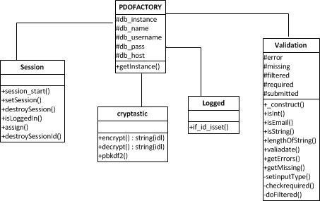

*(Source: Fieldwork, 2021)*

***Database Design***

The entities involved in this project are Roles, user information (User), and Chat. The entity relationship model gives a brief description of each of these entities and their individual attributes. This makes the arrangement of data in the database much more coordinated and the database design model easy to implement (Date, 2003).

The Role represents the authenticated user with the specialized privileges. The Role attributes are: id (the primary key. Data validation is switched on ensuring that the field is unique, i.e. no two records have the same id), and role (This field holds the various roles).

The User represents authenticated user without administrative privileges. The User attributes are: id (This is the primary key), userid (This key field identifies a person in the chat system. Data validation is switched on ensuring that the field is unique), password (key field to hold the password of the user), username (These two fields hold the user’s name), email (The email field is not essential and is just there so that if users have any problems, then the administrator can contact them), isActive (The status field tracks whether the user is currently online. This field is set by the login and logout scripts), gender (this holds the gender of the user), image (this field holds the reference to the location where the user’s profile picture is saved), and roleid (this is a foreign key referencing the role table, to identify the roles of the user).

The Chat represents actual messages during chat sessions. The Chat attributes are: id (This field is used as the primary key for the Chat table), msgid (This field holds the unique id of every message) date (This field holds the date and time the message was created), message (This field holds the actual text of the message), receiver (this field identifies the receiver of the message being sent), sender (this field identifies the sender of the message being sent), files (this field holds the files sent), seen(this field specifies if a message has been seen or not), received (this field specifies if a message has been received or not), deleted_sender (this field specifies the deleted message by the sender) and deleted_reciever (the field specifies the deleted message by the receiver). The attendant entity relationship diagram is presented in Figure 4.

Figure : Entity Relationship Diagram

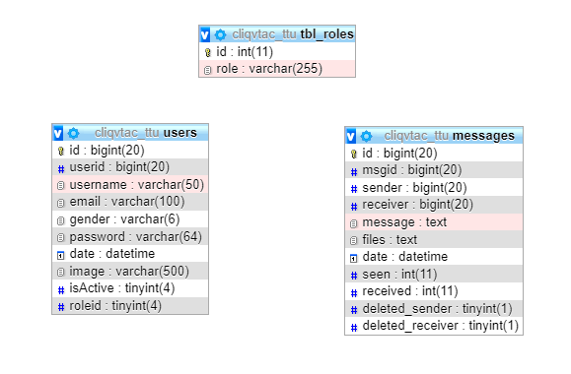

*(Source: Fieldwork, 2021)*

***Implementation and Testing***

This section focuses on the implementation of the functional application and the test for defects and necessary properties such as performance and reliability. These tests involve the execution of the application with test data to ensure that all requirements were implemented correctly and that the required quality characteristics were present in the finished product to ensure the deployment of a flawless system.

***Component Testing***

The major components of the system that were considered are the database and the interface. Component testing was done on individual components in the system to ensure that the system is completely exclusive of faults. Database Testing – An ideal test for this database would be one that ensures that all domain constraints are properly implemented. In order to reduce the complexity of the system, most of the contents of the application were stored in the codes while the dynamic contents were stored in the database. The most critical components of a database are the tables because they are the actual content-holders created to retain a set of related data. The database management system (DBMS) confirms whether all integrity rules governing the tables have been implemented before any data is stored. The domain constraint is the most important of these rules as it gives the allowable values for the attributes of any data. The screen shots of the database tables (Figures 5 to 7) coincide with, and therefore confirm that domain constraints are duly implemented.

Figure : The Message Table

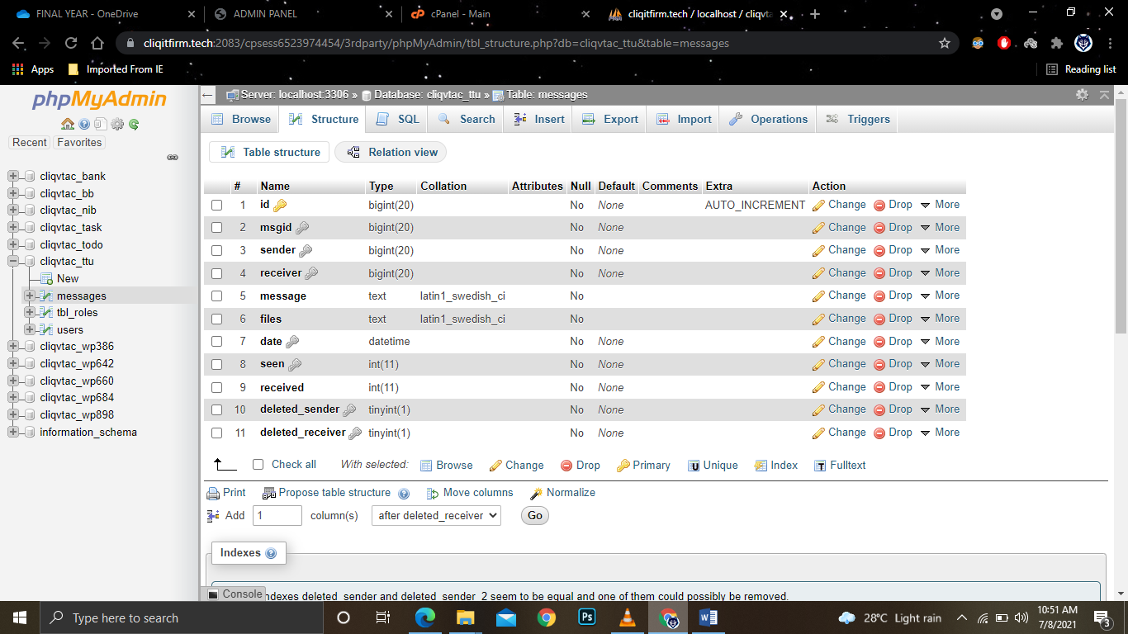

*(Source: Fieldwork, 2021)*

Figure : The User Table

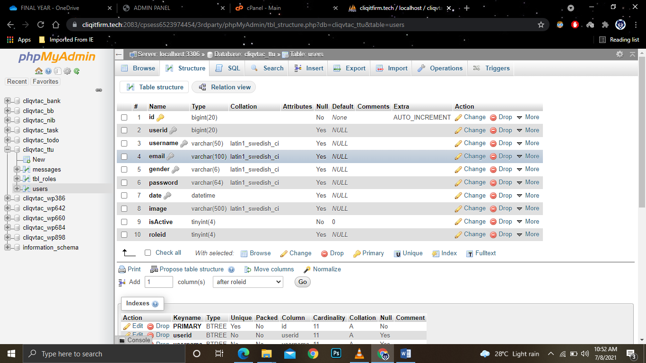

*(Source: Fieldwork, 2021)*

Figure : The Role Table

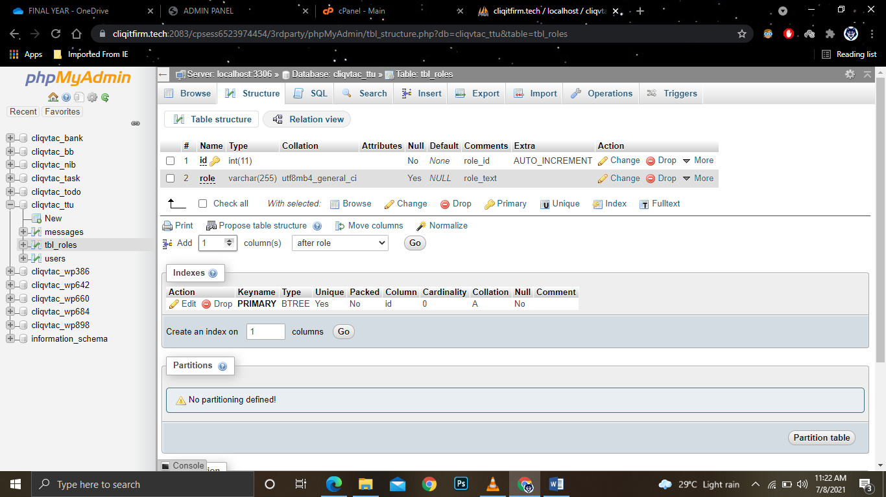

*(Source: Fieldwork, 2021)*

The interface of the system was tested using the Black Box Testing technique, which is based on an analysis of the specification of the system without reference to its internal workings. This was performed by those individuals who have no real knowledge of how the software works to also test ease of usage. Features of the system that are expected to be sensitive to data were tested in this phase.

Login Module Testing was conducted. From the system analysis conducted previously, access denial is expected for any login attempt without authenticated credentials (username and password). It was deduced that an ideal test for the login module would be one in which a user attempts to login to the system without valid details and empty details. The Figures 8 and 9 show the outputs of the test; an error message being displayed as the user attempts to access the system with invalid data (Figure 8) and user attempt to login with empty fields (Figure 9). Hence the login module is validated.

**User Interface**

Figure : The Login Page Message (invalid data entry)

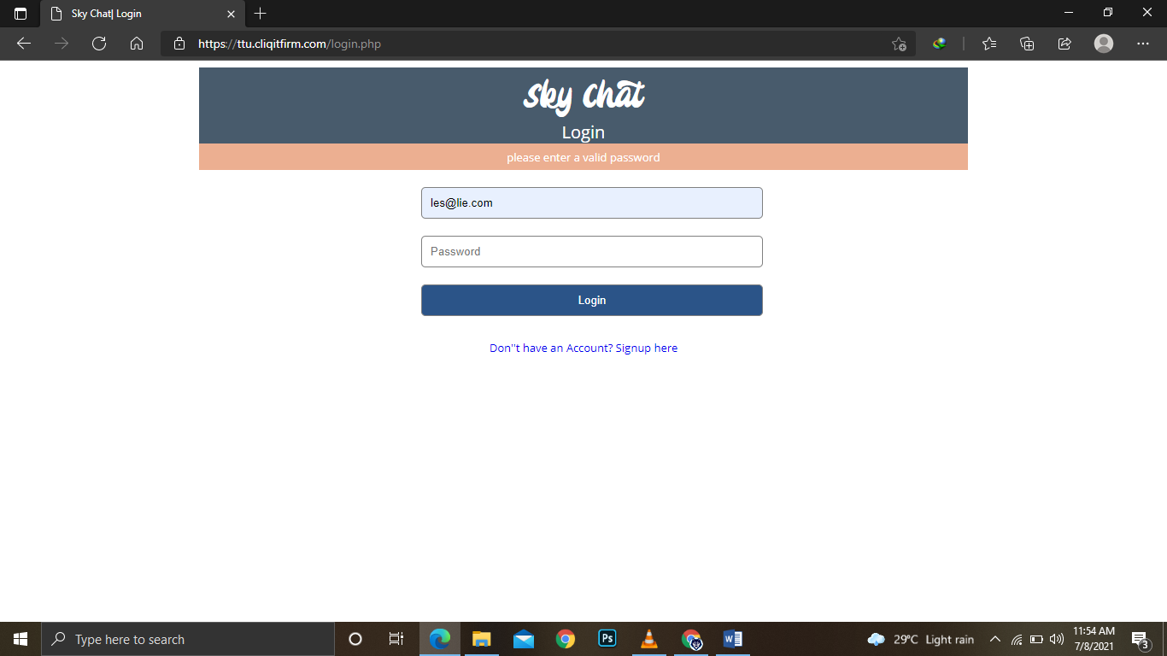

*(Source: Fieldwork, 2021)*

Figure : The Login Page Message (empty fields’ trial)

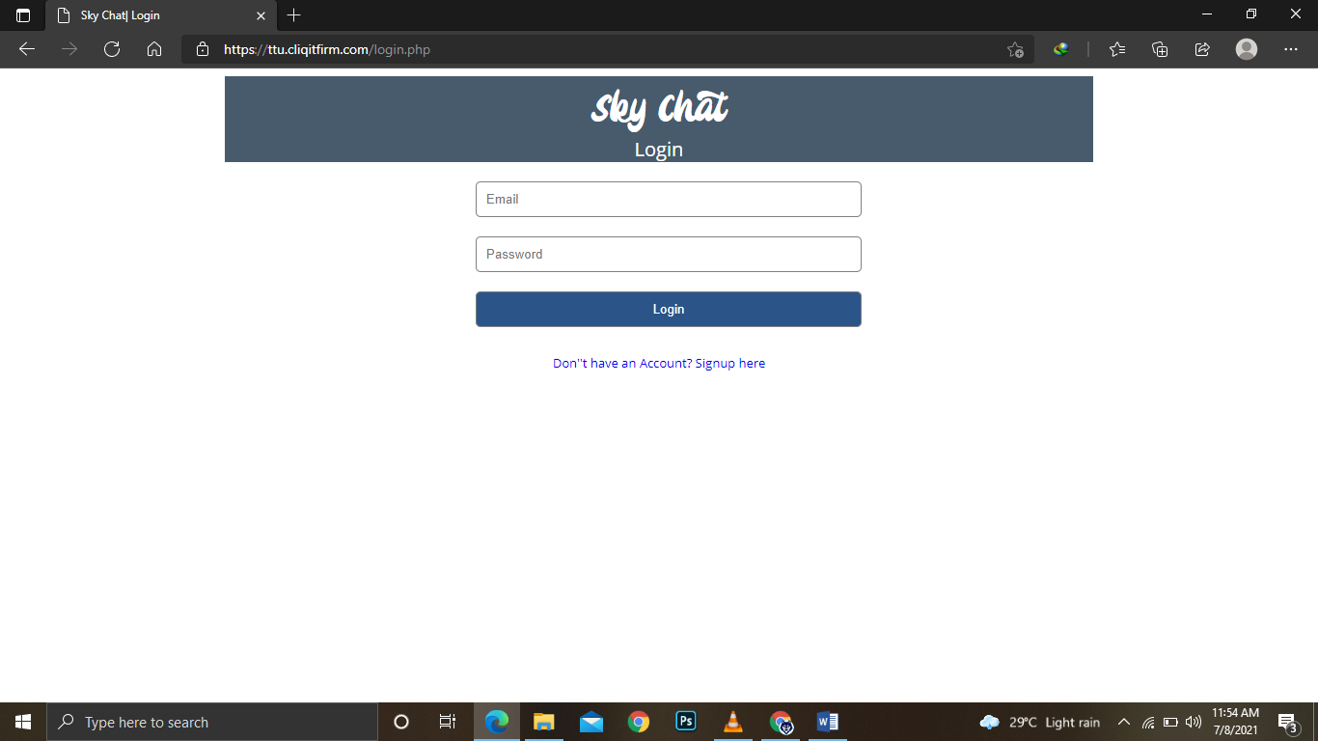

*(Source: Fieldwork, 2021)*

General Module Testing was done to ensure that the system will not permit any form of conflicting situation. The images below show the output of a test executed where, in the course adding new users with the same username, invalid email address the same email address for two people.

Figures 10 shows successful login page and Figure 11 shows the output of successful user registration.

Figure : The Home Page (after a successful login)

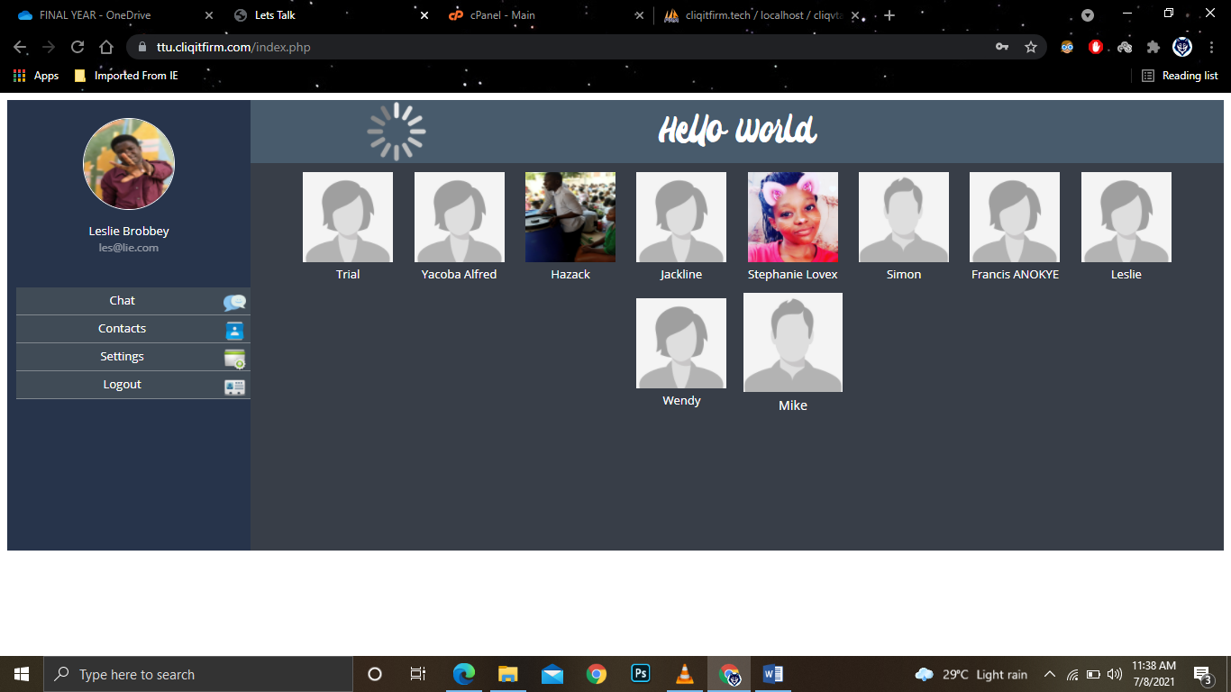

(Source: Fieldwork, 2021)

Figure : The Chat Page



*(Source: Fieldwork, 2021)*

Figure : The Settings Page (after a successful login)

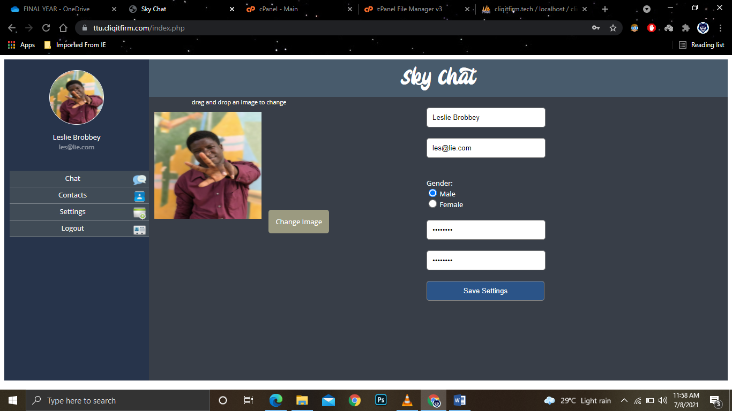

*(Source: Fieldwork, 2021)*

**Administrator Interface**

Figure : The Login Page Message (empty entry)

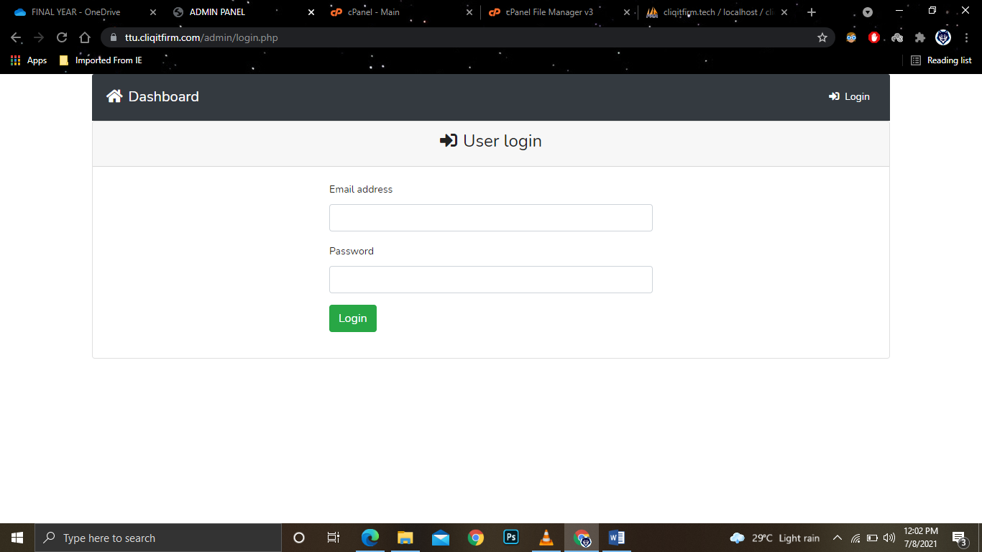

*(Source: Fieldwork, 2021)*

Figure : The Login Page Message (invalid data entry)

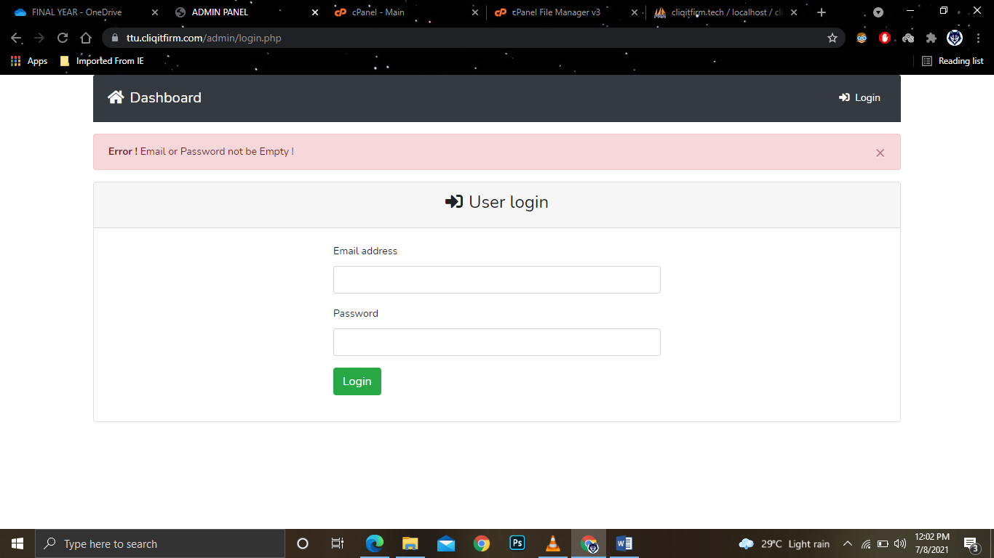

*(Source: Fieldwork, 2021)*

Figure : The Home Page (after a successful login)

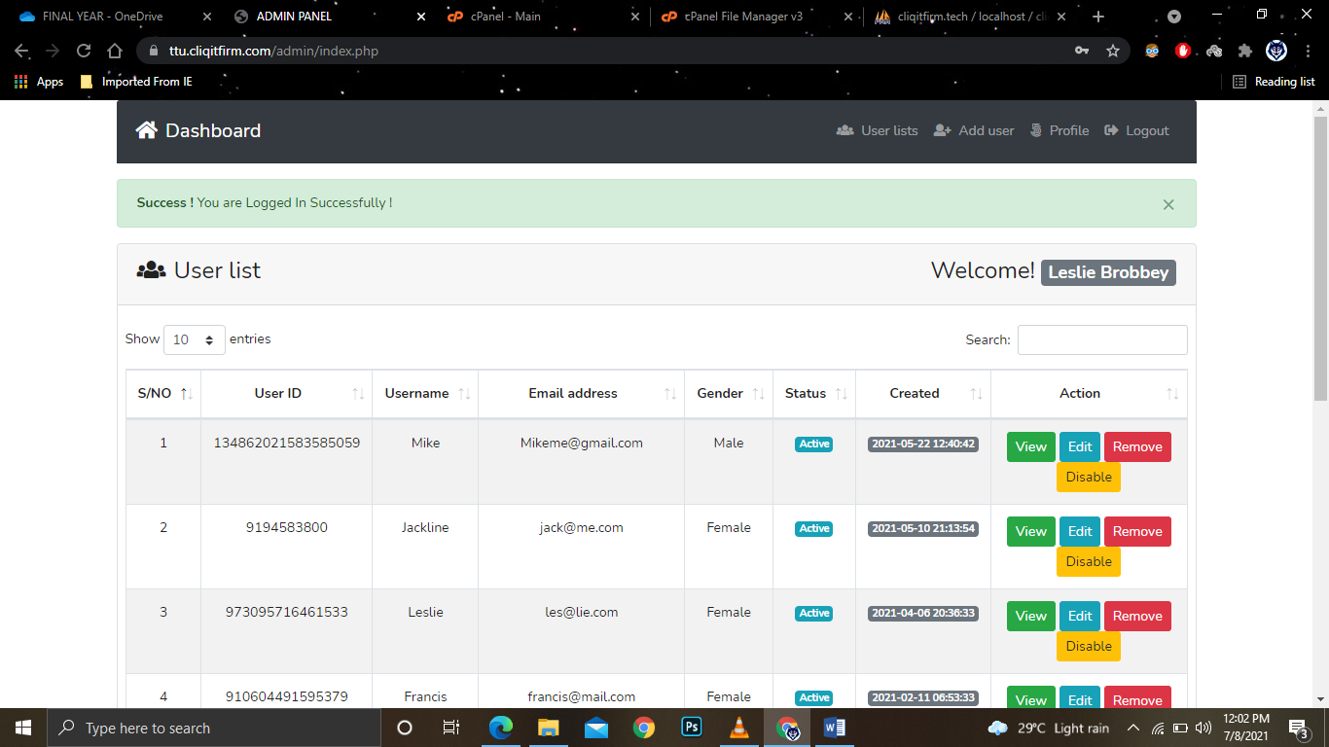

*(Source: Field work, 2021)*

Figure : The Profile Page (after a successful login)

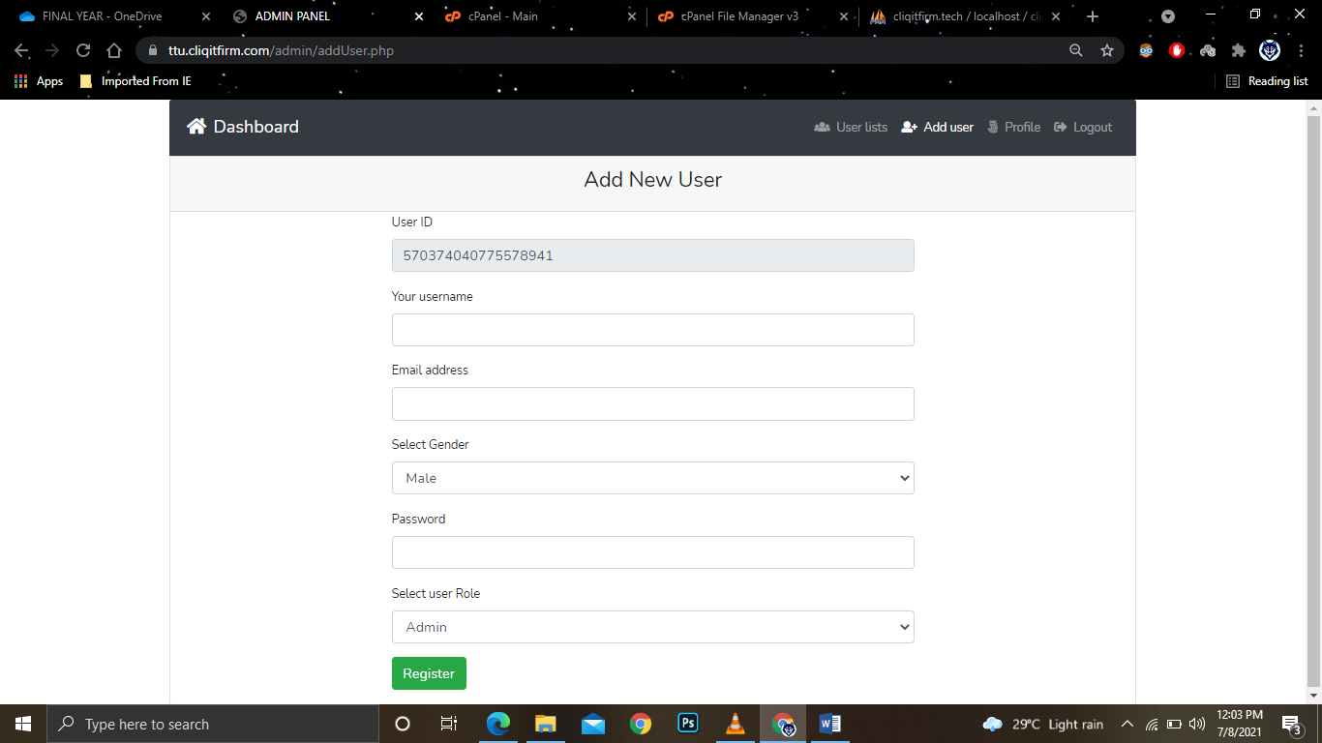

*(Source: Fieldwork, 2021)*

Figure : The Add New User Page (after a successful login)

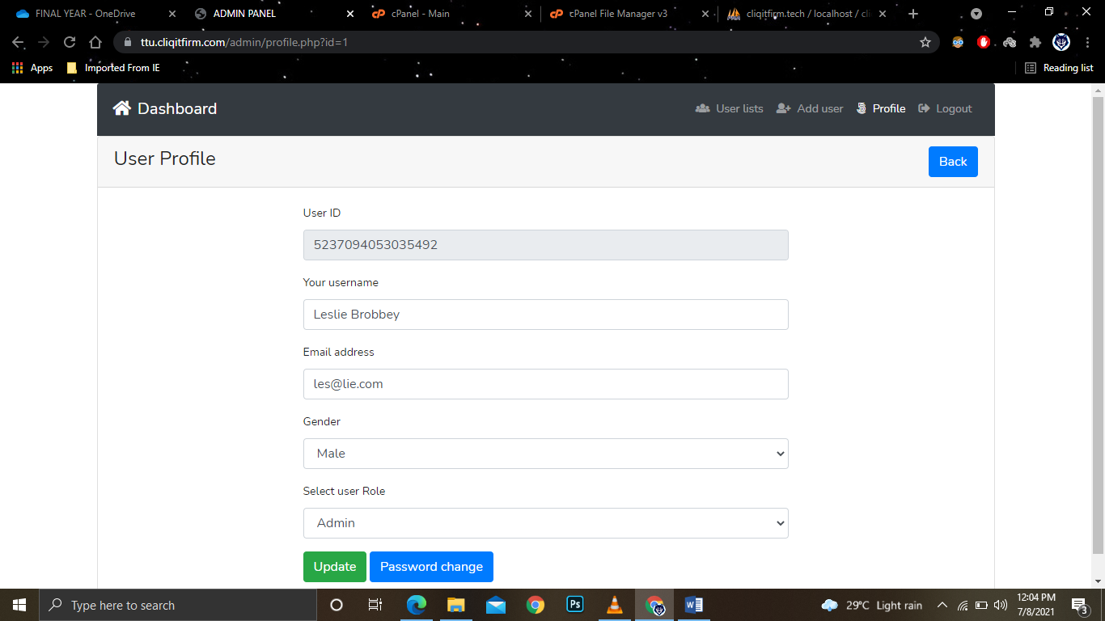

*(Source: Fieldwork, 2021)*

***Process Testing***

The entire workflow process was tested avoiding repeating tests. The processes of changing password and sending broadcast messages were noted here. Every user is expected to change the default password. Figure 18 shows the Change Password and Edit Profile Page.

Figure : Change Password and Edit Profile Page

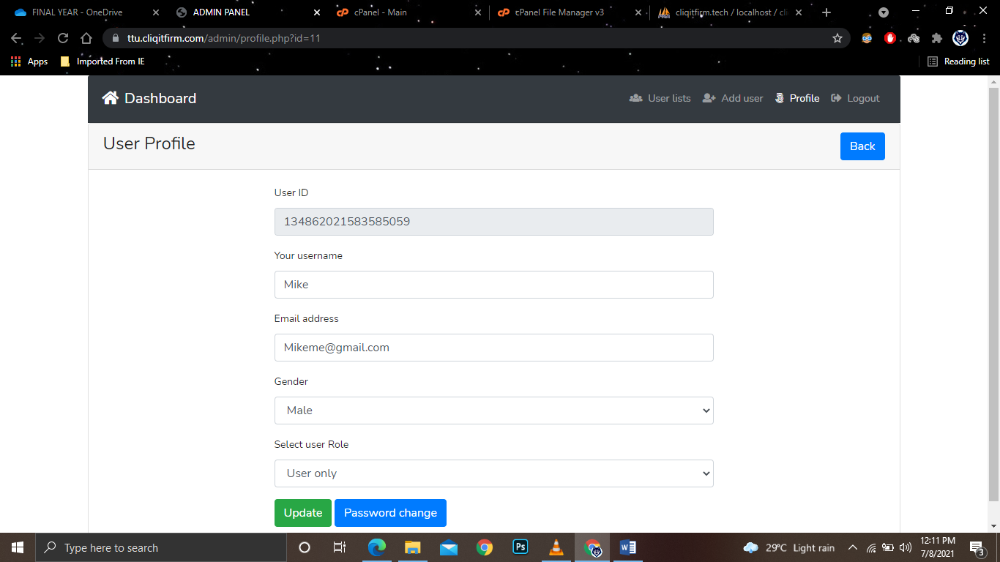

*(Source: Fieldwork, 2021)*

The Send test was done to test user friendly interface and also test the proper storage of inputted data of messages sent to others. Figure 19 shows the output of clicking Send without any input, and Figure 20 shows the window of messages. Figure 21 shows the window where sent messages could be viewed, and Figure 22 shows the all Users in the system.

Figure : Output of Clicking Send without any Input

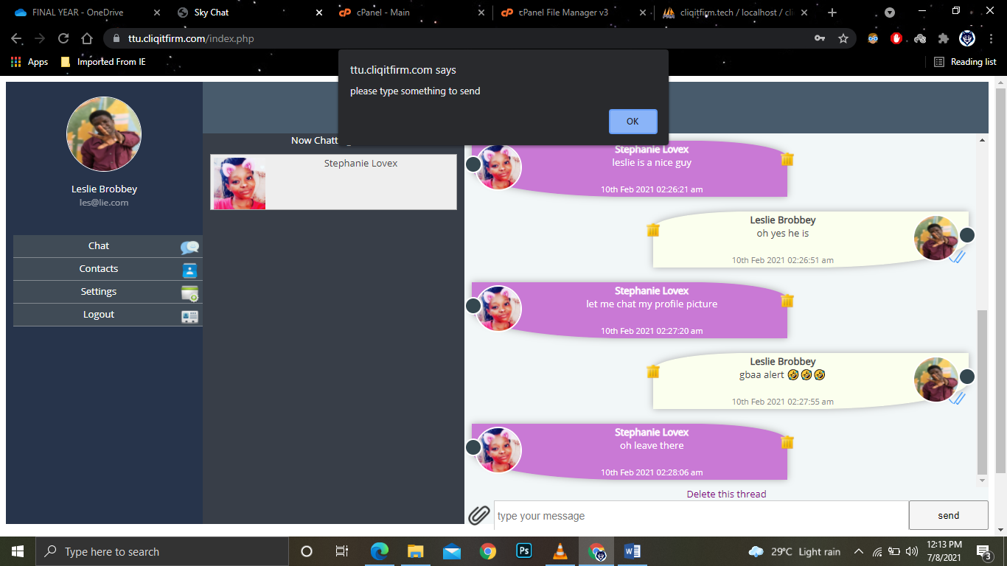

*(Source: Field work, 2021)*

Figure : Reading Messages



(*Source: Fieldwork, 2021)*

Figure : Viewing of sent messages



(*Source: Fieldwork, 2021)*

Figure : Users in The System

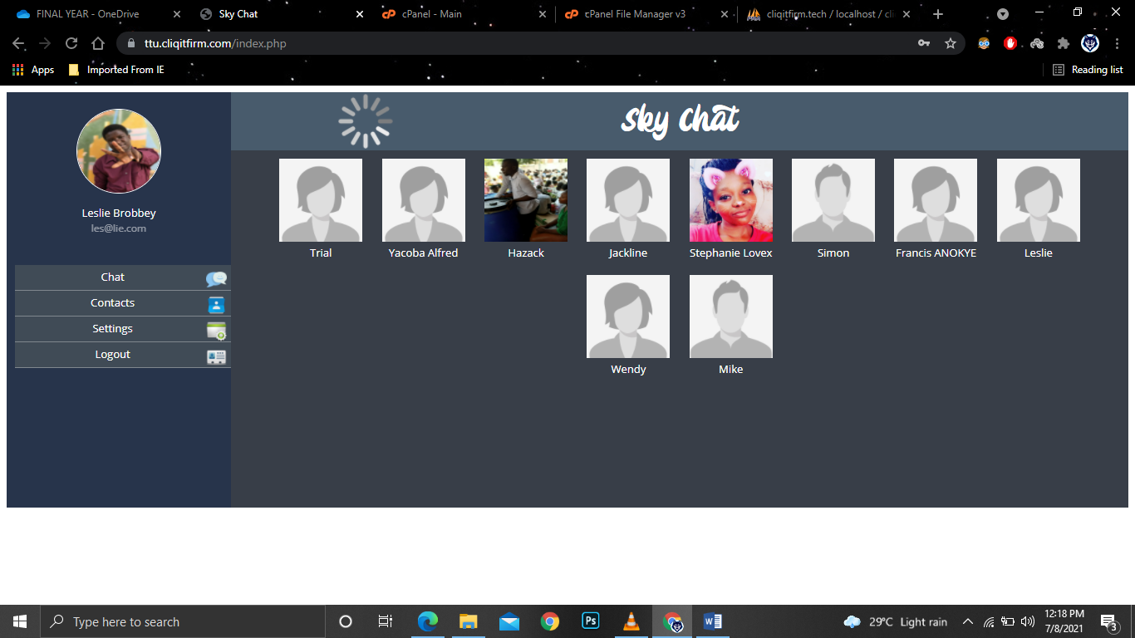

(*Source: Fieldwork, 2021)*

***Application Platform***

The minimum hardware and the software requirements are: physical memory (RAM) of 512MB; Intel, Celeron or AMD Pentium 3 processor; hard disk capacity of 5 GB; Windows (98, 2000, ME, NT, XP, Vista, 7), Linux, or Mac OS; JavaScript-enabled web browsers (Mozilla Firefox (most suitable), Internet Explorer, Google Chrome, or Opera-mini), and Virtual server (Xampp version 1.7.1, Wamp server).

**Related Works**

One of the most important phases in the Internet chat history was the introduction of Internet Relay Chat (IRC) which was developed by Jarkko "WiZ" Oikarinen in 1988 at University of Oulu, Finland, where he was working at the Department of Information Processing Science. By the year 1989, there were already 40 servers that were provided with this service. Gradually, IRC started to gain popularity and was made available in almost sixty countries (Oikarinen & Reed, 1993). A number of other chatting programs were also developed in the attempt to replace IRC. IRC and Dalnet proved to be the most viable developments in the entire Internet chat history.

Groundbreaking innovations have further advanced the chatting methods and techniques. There are different types of Chat enabled today like Voice Chat and Video Chat. The chat systems voodoo, GoogleTalk, Skype and Facebook are discussed in succeeding paragraphs.

Voodoo Chat, opened in very late December 2001 is a text-based chat program with voice chat features created in the wake of Excite’s Virtual Places closure due to the company's bankruptcy following acquisition by the @Home Network (Parniak, 2009). Voodoo Chat uses two methods of security. The first is encryption. The second is the use of system hashes. It has the hub server which organizes other servers, login server which is a firewall and the chat server that controls the chat process. The limitations of Voodoo include that a user is restricted to a particular computer: once a user’s computer is registered, the user cannot use another computer to chat, and if the computer is stolen, there is an easy access to penetrate into the server.

SkyChat Chat System Characteristics include calling another player (having gotten the player’s TCP/IP address, and what port to use for chatting), receiving calls from one or more other players, and validating incoming calls and accepting or rejecting them. It enables splitting of users into groups, allows chats with the group members, and enables sending or receiving of files from other members. Its limitations include low security level: the chat system is prone to attack by penetration (Gammon, 2005). SkyChat Chat System is a peer to peer chat system.

Google Talk is an instant messaging service that provides both text and voice communication. Google Talk applications are available for Microsoft Windows (XP, Server 2003, Vista, and Windows 7), Android, Blackberry, and Google Chrome OS operating systems. Because the Google Talk servers communicate with clients using an open protocol, XMPP, the service can also be accessed using any other client that supports XMPP. The connection between the Google Talk client and the Google Talk server is encrypted, except when using Gmail's chat over HTTP, a federated network that does not support encryption, or when using a proxy like IMLogic. End-to-end messages are unencrypted. Some XMPP clients natively support encryption with Google Talk's servers (Betabeat, 2012; Google Talk Beta, 2011; Google Talk Help, 2013). The technology used within the Google server network, however, is not publicly known. Its limitations include being prone to attack when chatting over HTTP or IMLogic.

Skype is a web application that uses the internet to make transmit messages. It also offers video, chat, SMS and presence awareness all in one application (Higginbotham, 2008). With the exception of logon servers, Skype has no central server to maintain the network. Instead, Skype uses peer to peer technology to decentralize the network and to help ensure a very high uptime percentage. Once you log in to Skype, your system becomes part of the network itself helping to decentralize the load of routing phone calls. Skype has an encryption system for security. This system cannot be turned on or off. Skype provides an uncontrolled registration system for users. People can use the system safely without revealing their real-life identity to other users of the system, but there is no way to know that the person they communicate with is the one they say they are. By using VoIP to make the calls, it is very cheap to call another phone. It does not cost money to call another Skype user. Every Skype user has a unique username which other users can use to talk with them (Wikipedia Skype, 2013). One of Skype limitations is lack of privacy (Skype has the keys to decrypt calls or sessions). Skype also makes it hard to enforce a (corporate) security policy. In addition, there are bugs and delays in the Linux version.

Facebook is the second largest social network on the web, behind only MySpace in terms of traffic (Yadav, 2006). Facebook tends toshare user information with third parties, including companies with which they have a relationship. Hence, privacy is not totally assured. Facebook also collects information about users from other sources, such as newspapers and instant messaging services. This information is gathered regardless of use of the website.

# CHAPTER 5

## CONCLUSION AND RECOMMENDATION

### 5.1 Introduction

The project successfully delivered on all requirement specification specified by the user. Care was ensured during the design to make sure data integrity is maintained and to avoid all forms of redundancies associated with data.

The user is assured a very friendly interface, behind which there are wide ranging technical details that went in. The user guide is a mere formality because, the project was specially created bearing in mind interaction and designs that would make users feel as though they have used a system such as this.

This project has also been built in such a manner that future changes or modifications that are required can easily be implemented without affecting the functionality of the system. This project is used on the web and can be used on any web browser so it can be used by anyone. The technical document that is provided in the report of this project will help developers understand the internal workings of the system.

### 5.2 Objective Assessment

After building the system, we achieved these objectives:

* We were able to develop a multi lingual chat application
* We were able to develop an interactive system that incorporated Pidgin English into chatting
* We were able to evaluate the existing literature of instant messaging

.

### 5.3 Challenges

The following challenges were observed after development of this system

* Only registered users can use the system
* Internet must be available to use the application
* There must be minimum of two users per time for interactive chatting

### 5.4 Future Enhancements

* Video calls will be added
* Voice recording can be added
* Enhancing different text style and font size
* Introduction of animations
* Instant document attachment

### 5.5 Recommendations

Research done in regard to this project, coupled with the fact that we now live in a world that everything is now becoming digitalized, the following recommendations were derived:

* The development of chat application shouldn’t and wouldn’t stop here, constant improvement and research needs to be conducted to make sure it is in line with best technology practices.
* The development of local content chatting application should be encouraged as this will help improve the economy of Ghana.
* Every class of the societal stratification should be encouraging to use this localized chatting application as it improves our education standard and exposure to the outside world.

### 5.6 Summary

Web messaging apps now have more global users than traditional social networks—which mean they will play an increasingly important role in the distribution of information in the future. While chat platforms initially rose to prominence by offering a low-cost, mobile message app alternative to SMS, over time they evolved into multimedia hubs that support photos, videos, games, payments, and more. To harness the growing population of Africa in general and Ghana in particular was the introduction of the Pidgen English chatting leverage, which is unique in its own right.

# References

1. Arthur, F. A. (2018). *Computer Literacy Guide (Second Edition).* Takoradi: Takoradi Technical Universiy.
2. Graeme McLeana, K. O.-F. (2019). *Chat now… Examining the variables influencing the use of online live chat.* Retrieved from Science Direct: https://www.sciencedirect.com/science/article/pii/S0040162518305122
3. Molly McKinney (19 November 2018). *"Sell a Couch or Make a New Friend: Broadcast Provides Potential Mind Games and Hookups."* The Wooster Voice, November 19, 2018, p.8"
4. The 'Security Digest' Archives (TM) : TCP-IP Distribution List for February 1989".*securitydigest.org*. Archived from the original on 8 December 2017.
5. "*CompuServe Innovator Resigns After 25 Years*", The Columbus Dispatch, 11 May 2016, p. 2F.
6. Mike Pramik, "*Wired and Inspired*", The Columbus Dispatch, (Business page), 12 November 2000.
7. "*IRC Chatiquette – Chat Etiquette*". Livinginternet.com. 28 November 2015. Retrieved 19 January 2012.
8. "*BBC - WebWise - How do I use instant messaging (IM)?*". Uits.uark.edu. Archived from the original on 3 July 2017. Retrieved 1 August 2017.
9. *Using the Internet for Active Teaching and Learning*, Steven C. Mills Archived 19 October 2008 at the Wayback Machine ISBN 0-13-110546-9
10. CNET reviews - comparative reviews - chat clients - chatiquette The Internet Archive. Source:https://web.archive.org/web/20161221112318/http://www.cnet.com/Content/Reviews/Compare/Chat/ss07.html
11. Regina Lynn (4 May 2007). "*Virtual Rape Is Traumatic, but Is It a Crime?*". Wired. Archived from the original on 20 December 2014.
12. Viatcheslav Yatsko "Texor". Yatsko's Computational Linguistics Laboratory. Archived from the original on 1 November 2014. Retrieved 29 June 2013.
13. Liberman, Mark. Language Log: Texting and language skills Archived 15 January 2013 at the Wayback Machine, University of Pennsylvania, 2 August 2012.
14. Merchant, Guy . "Teenagers in cyberspace: an investigation of language use and language change in internet chatrooms." Journal of Research in Reading. 2001, Vol. 24, Iss. 3, ISSN 0141-0423.
15. Topping, Alexandra (10 June 2009). "'Web 2.0' declared millionth word in English language". The Guardian. Archived from the original on 24 October 2016.
16. SkillsYouNeed (2020) *What is Communication?*[online] available at www.skillsyouneed.com/ips/what-is-communication.html (Accessed October 14 2020) Read more at: https://www.skillsyouneed.com/learn/academic-referencing.html
17. Page J, Hinshaw D, McKay B (26 February 2021). "*In Hunt for Covid-19 Origin, Patient Zero Points to Second Wuhan Market – The man with the first confirmed infection of the new coronavirus told the WHO team that his parents had shopped there*". The Wall Street Journal. Retrieved 27 February 2021.
18. Zimmer C (26 February 2021). "*The Secret Life of a Coronavirus – An oily, 100-nanometer-wide bubble of genes has killed more than two million people and reshaped the world. Scientists don't quite know what to make of it*". Retrieved 28 February 2021.
19. CDC. 2019 *Novel Coronavirus, Wuhan, China*. CDC. Available at https://www.cdc.gov/coronavirus/2019-ncov/about/index.html. January 26, 2020; Accessed: January 27, 2020.
20. Yvonne Taunton (September 08, 2020) *How has COVID-19 affected the way we communicate?*
21. Bangthetable (2020) *What are the disadvantages of online communication for community engagement?* Source: https://www.bangthetable.com/blog/disadvantages-of-online-communication/
22. Gao, Kevin. "*5 Best Practices for Increasing Sales with Live Chat Software*". Salesforce. Retrieved 23 September 2014.
23. "*CSS developer guide*". Mozilla Developer Network. Archived from the original on 2015-09-25. Retrieved 2015-09-24.
24. Flanagan, David. *JavaScript – The definitive guide* (6 ed.). p. 1. JavaScript is part of the triad of technologies that all Web developers must learn: HTML to specify the content of web pages, CSS to specify the presentation of web pages, and JavaScript to specify the behavior of web pages.
25. "*PHP: Hypertext Preprocessor*". www.php.net. Retrieved 2020-02-12.
26. Greycampus, “*Object-Oriented Programming In PHP*” https://www.greycampus.com/codelabs/php/OOPS
27. Fielding, Roy T.; Gettys, James; Mogul, Jeffrey C.; Nielsen, Henrik Frystyk; Masinter, Larry; Leach, Paul J.; Berners-Lee, Tim (June 2009). *Hypertext Transfer Protocol – HTTP/1.1*.IETF. doi:10.17487/RFC2616. RFC 2616.
28. Flanagan, David. *JavaScript - The definitive guide* (6 ed.). p. 1. JavaScript is part of the triad of technologies that all Web developers must learn: HTML to specify the content of web pages, CSS to specify the presentation of web pages and JavaScript to specify the behaviour of web pages.
29. "Usage statistics of JavaScript as client-side programming language on websites".*w3techs.com*. Retrieved 2021-04-09.
30. *"Usage statistics of JavaScript libraries for websites". w3techs.com. Retrieved2021-04-09.*
31. W3Schools, “*PHP – AJAX Introduction”* https://www.w3schools.com/php/php_ajax_intro.asp
32. SiteGround (2021), “*What is SQL and MySQL”,* [*https://www.siteground.com/tutorials/php-mysql/mysql/*](https://www.siteground.com/tutorials/php-mysql/mysql/)
33. Betabeat. (2012). Google Says GChat is not a word. Retrieved from: http://www.betabeat.com/2012/02/10/google-says-gchat-is-not-aword/
34. Chamberglain, R., William, M. And Jarred, A. (2008). Practicum Chat Application: Requirements specification document. Retrieved
35. from: http://simplechat.org/docs/project6_design_document.pdf
36. Date, C. J. (2003). An Introduction to Database System. Delhi: Pearson Education
37. Finkler, J. and Dao, D. (2001). Chat Application Requirements. Retrieved from:
38. www.eveandersson.com/arsdigita/doc/requirements/chat_req_updated
39. Gammon, N. (2005). MUSHclient’s Features. Retrieved from: www.gammon.com.au/mushclient/chat.htm
40. Higginbotham, B. (2008). Skype. Retrieved from: www.technologyevangelist.com/2008/05/a_bit_about how_skype.html
41. Google Talk Beta (2011). What’s New on Google Talk? Retrieved from: http://www.google.com/talk/whatsnew_more.html
42. Google Talk Help (2013). Google Talk. Retrieved from: https://support.google.com/talk/?hl=en
43. Hughes, B. and Cotterell, M. (2009). Software Project Management. London: McGraw-Hill Education
44. Parniak, M. (2009). Voodoo Chat. Retrieved from: http://en.wikipedia.org/wiki/Voodoo_Chat
45. Oates, B. J. (2009). Researching Information Systems and Computing. London: SAGE
46. Oikarinen, J. And Reed, D. (1993). History of Chat System: retrieved from: http://daniel.haxx.se/irchistory.html
47. Whitten, J.L., Bently, L.D., and Dittman, K.D. (2001). System Analysis and Design Methods. New York: Irwin/McGraw-Hill. Pp 13,
48. Wikipedia Online Chat (2013). Online Chat. Retrieved from: http://en.wikipedia.org/wiki/Online_chat
49. Wikipedia Skype (2013). Skype. Retrieved from: https://simple.wikipedia.org/wiki/Skype
50. Yadav, S. (2006). Facebook Profile. Retrieved from: <https://mashable.com/2006/08/25/facebook-profile>
51. G Akman (2016), A cryptographic approach for secure client-server chat application using public key infrastructure (PKI). Retrieved from: <https://ieeexplore.ieee.org/abstract/document/7856750/>